Incorporating Evaluation in Essay Writing
Your evaluation of sources should ultimately be seamlessly incorporated into your academic writing. Since your evaluation of sources is based upon what you found in your analysis, a number of analytical and evaluation skills should appear in each paragraph you write, alongside quotes from sources.

A simple way to do this is to introduce a quote by using some analysis or evaluation:

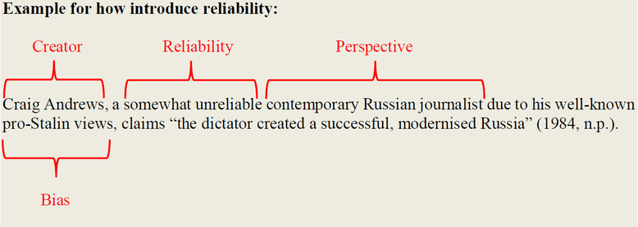
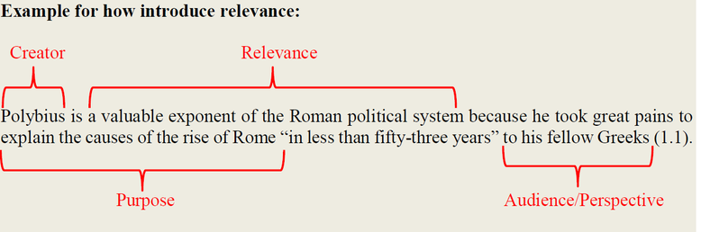
However, it is not always necessary to incorporate a quote into your analysis and evaluation of a source. This is especially true when you can interpret the overall theme or message of a source. In this manner, you can demonstrate analysis and evaluation without relying on a direct quote.

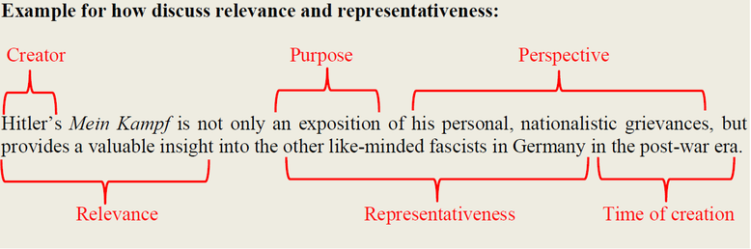
Below is an example body paragraph from an essay, showing the range of analysis and evaluation skills:

Example body paragraph:
Martin Luther King Jr. considered the 1963 Birmingham Campaign a necessity because of the harsh treatment of the African-American community. In mid-1962, King and other officials from the SCLC conceived ‘Project C’, which used the non-violent protest strategies of sit-ins, boycotts and daily marches, to draw public attention to the heavy-handed, and often violent, responses by the police. King’s justifications for this approach are explained in a telegram which he sent to President Kennedy in 1962, in which he stated that a “reign of terror is still alive in Birmingham Alabama [and] it is by far the worst big city in race relations in the United States” (King, 1962, 1). His reasons are explained further the following year, in a letter which King wrote while in jail in Birmingham following his arrest for taking part in the protests. In it, the civil rights leader argued that the protests were necessary since the city authorities left the African-American community with no alternative (King, 1963, 2). As this document was written with the expressed purpose of explaining the causes of the Birmingham Campaign, it is a particularly reliable record of King’s justifications for the event. As is clearly seen in these two sources, both written by King himself, he saw Project C as a vital step in gaining full rights for the citizens of the city. Therefore, King was convinced that the 1963 Birmingham Campaign was a direct result of the unjust treatment suffered by the African-Americans in Birmingham.

Colour key:
Information
Origin
Perspective
Context
Audience
Motive

